MASTER OF SCIENCE IN INFORMATION TECHNOLOGY
PETER IRUNGU MWANGI
SCT321-C004-2079/2018
MIT 3102 BUSINESS INTELLIGENCE
------------------------------------------------------------------------------------------------------PREDICTIVE ANALYTICS: DECISION TREE
Task:
{Create a csv for square root of numbers from 1 to 350 and save it as squareroot.csv.
Using this data predict the square root of 500. (Use decision tree to predict the square root of 500)}
Introduction
Predictive analytics can be defined as a form of advanced analytics, which uses both new and historical data to forecast activity, trends and behavior. This involves application of statistical analysis techniques, analytical queries and automated machine learning algorithm to data sets, to create a predictive model(s) which places a numerical value/score on the likelihood of a given event happening.
The predictive analytics relies heavily on advanced algorithms and methodologies, this includes logistic regression models, time series analysis and decision trees.
For this task, will use decision tree to predict the square root of 500 from the dataset of square roots of numbers ranging from 1 (one) to 350 (three hundred and fifty).
Decision Tree
A decision tree refers to a graph that uses a branching method to illustrate every possible outcome of a decision. It is arguably the most popular classification technique in the data mining arena.
Decision trees include many input variables that may have impact on the classification of different patterns, this variables are known as attributes. A tree consist of branches and nodes. Branches represents the outcome of a test to classify a pattern using one of the attributes. A leaf node ate the and represents the final class choice for a pattern of branches from the root node to the leaf node (this can be represented as a complex if statement)
The basic idea behind a decision tree is, it recursively divides a training set until each division consists of an example(s) from one class.
A general algorithm for building a decision tree is as follows:
- Create a root node and assign all of the training data to it.
- Select the best splitting attribute.
- Add a branch to the root node for each value of the split. Split the data into mutually exclusive (no overlapping) subsets along the lines of the specific split and move to the branches.
- Repeat steps 2 and 3 for each and every leaf node until the stopping criteria is reached (e.g., the node is dominated by a single class label).

Solving the task using decision tree
{Create a csv for square root of numbers from 1 to 350 and save it as squareroot.csv. Using this data predict the square root of 500. (Use decision tree to predict the square root of 500)}
Create a dataset for square roots of numbers from 1 to 350 as squareroot.csv
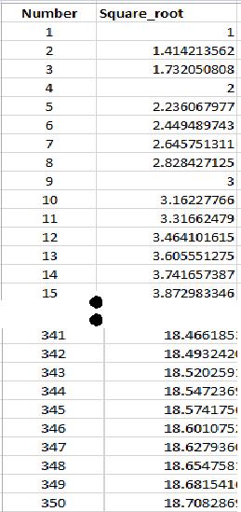
Create the parameters from the squareroot.csv into the applet as shown below.
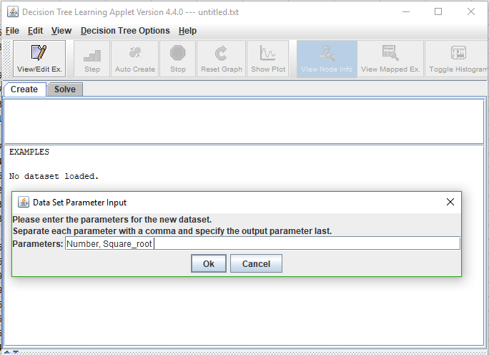

Load the squareroot.csv file to the applet to get the training examples as shown below
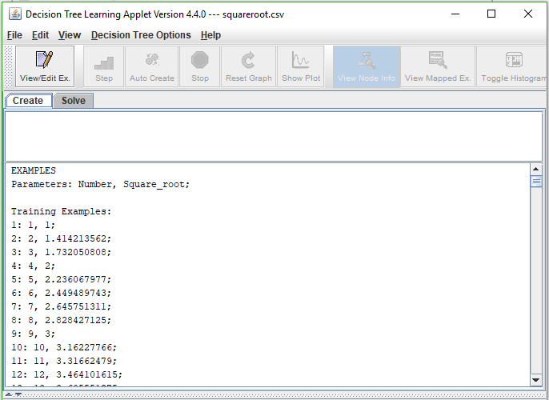

From the example dataset squareroot.csv, edit the set examples to have a training examples and test examples. To achieve this, I have randomly selected 50% of the training example to create a test example dataset as shown below.
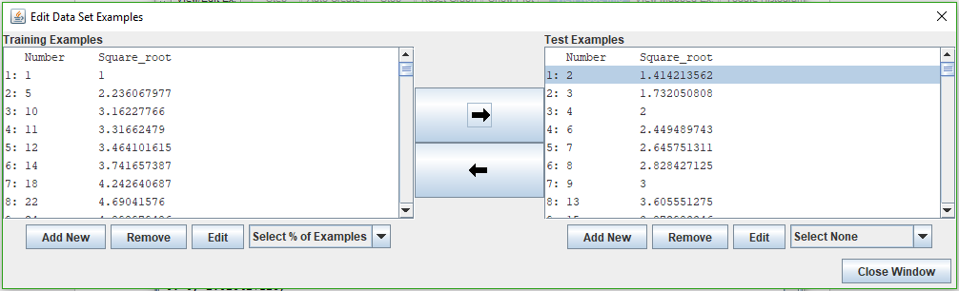

After separating the two datasets. Clicked on solve, and from here am able to get the summary information of the node created, as shown below.
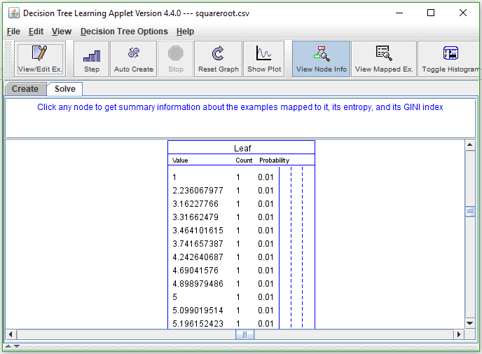

To get split node. Selected the node I created, then choose the number attribute to split on as shown below.
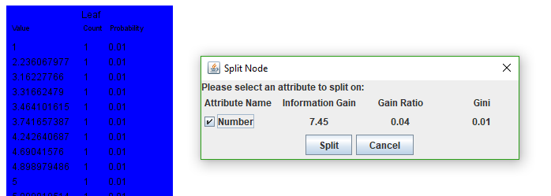
Other information genetrated from the applet
Node information | Mapped examples of datasets
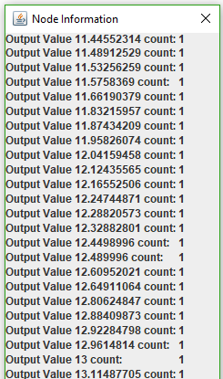 | 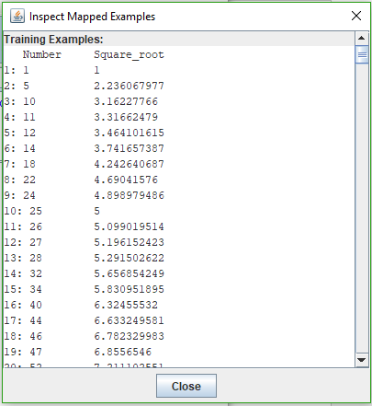
Error plot
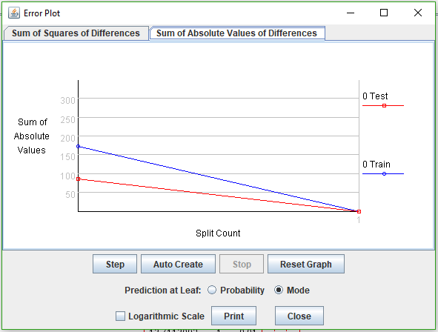

Solution
Predicting the square root of 500.
Simplified the dataset by selecting 2% of the data from the dataset
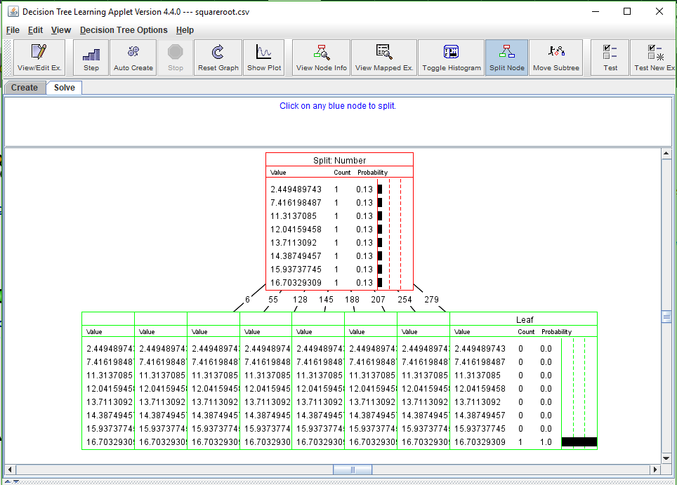

Using the test example, output value to get the squareroot of 500.

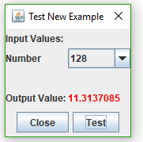 | The predicted output value for the squareroot of 500 is approximately 44.19417.
  Number | Squareroot
  128 | 11.3137085
  500 | (500 * 11.3137085)/128 = 44.19417

